**Description**

**Author**: Tran Huynh

**Course**: CS651

**Project R1**

**Name of Application**: Photosite

**Description**: Showing all user list and photos which belong to each user with comments from other users

**Youtube**: https://youtu.be/kSoMfYI5EOM

**Demonstration**

List of all users:

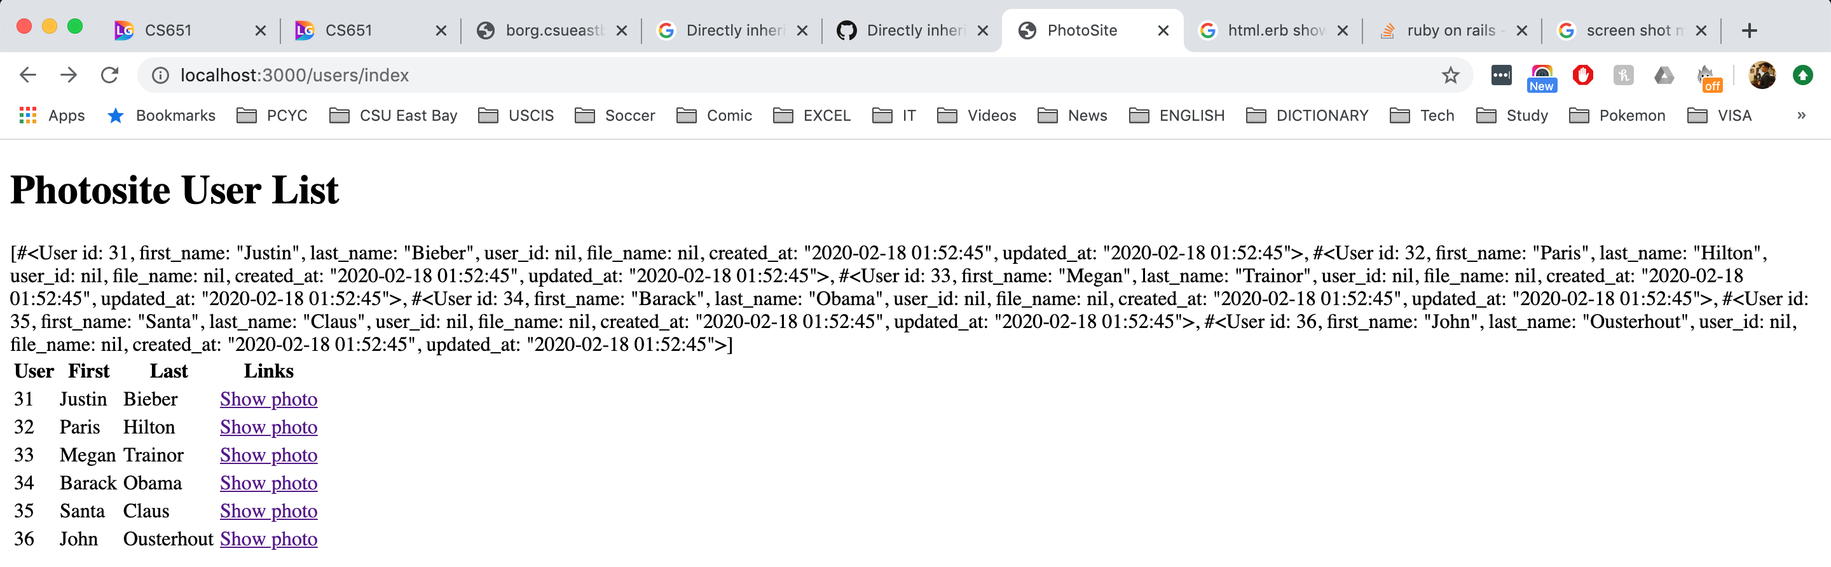

Photo site:

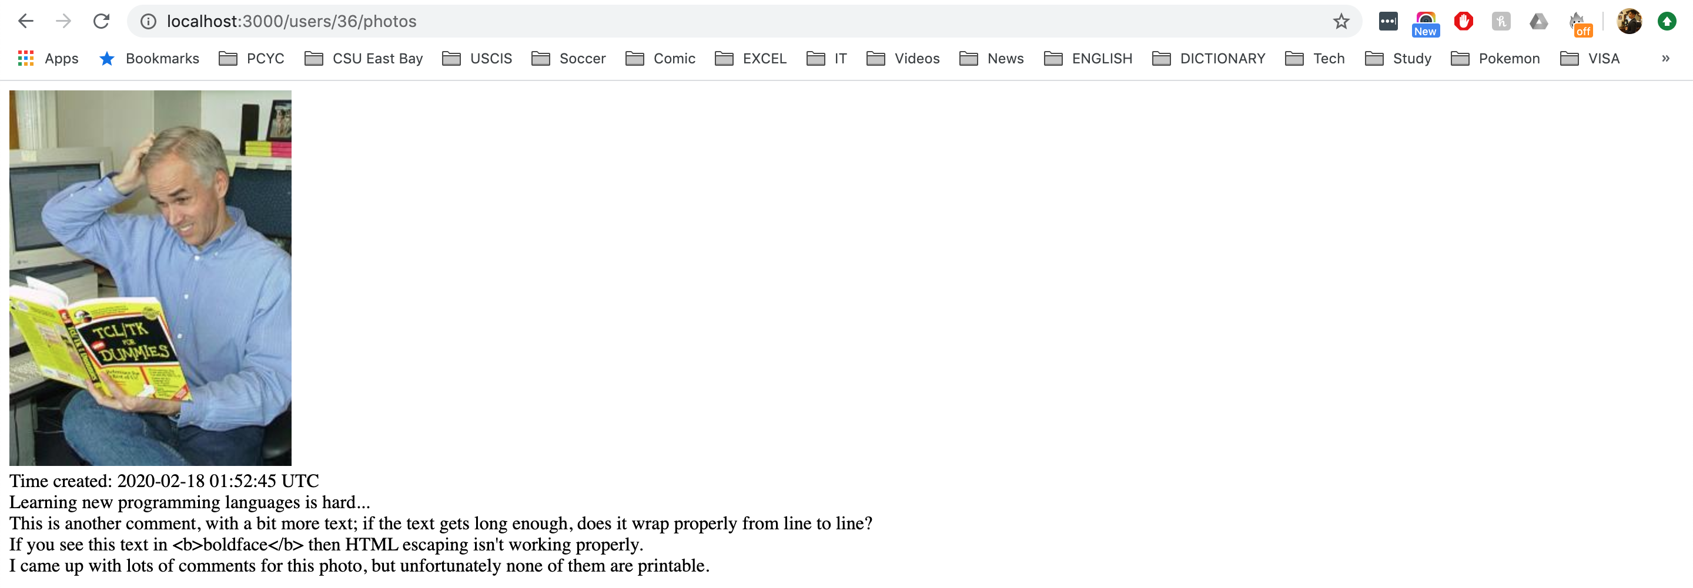

**Issues**

Display issue: (already fixed)



HTML view file

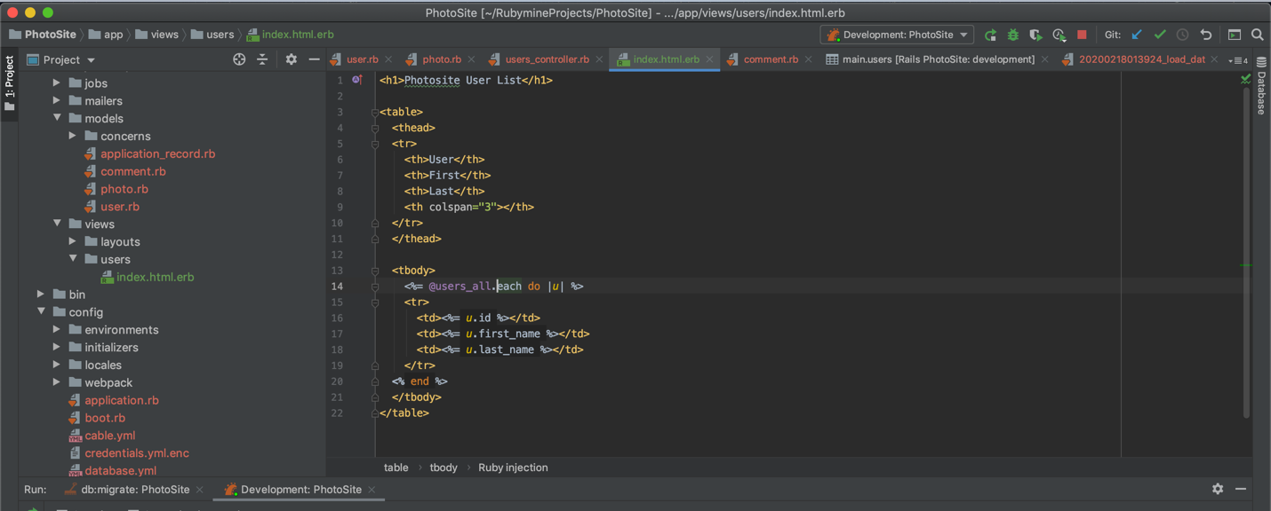

Error viewing images: (already fixed)

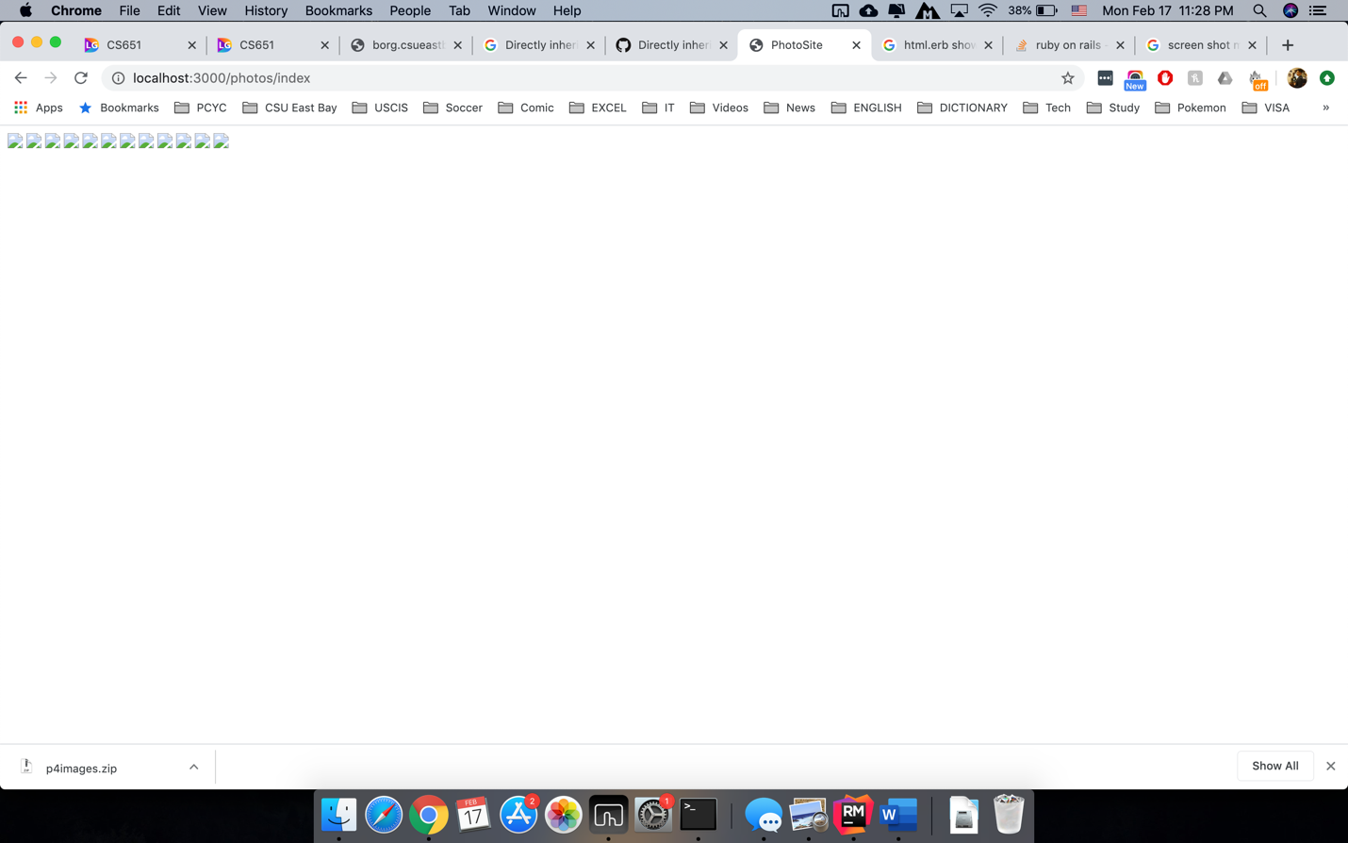

HTML view file:

